COMP7012
IT Project Management
Lab Exercise 4

Kathlyn Kelly, R00177109

Today’s Lab exercise focuses on one of a project’s financial feasibility.

- Calculate the Net Present Value (NPV) for each of the projects A, B, and C shown in below Table using each of the discount rates 8%, 10%, and 12%. For each of the discount rates, decide which is the best project. What you can conclude from these results? Do not engage in a “copy-and-paste” exercise (30 mins)
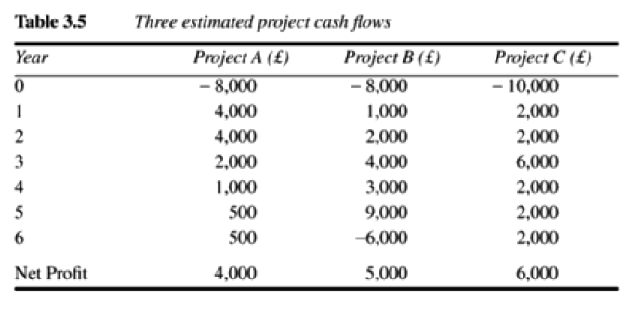
NPV @ 8% 2,111 2,365 2,421
NPV @ 10% 1,720 1,818 1,716
NPV @ 12% 1,356 1,308 1,070

To find the NPV I used the formula Cash Flow / (1 + i) ˆt

NPV @ 8% (Project A) = -8000/(1 + 0.08)^0 + 4000/(1 + 0.08)^1 + 4000/(1 + 0.08)^2 + 2000/(1 + 0.08)^3 + 1000/(1 + 0.08)^4 + 500/(1 + 0.08)^5 + 500/(1 + 0.08)^6 = 2111.13 = 2111

NPV @ 8% (Project B) = -8000/(1 + 0.08)^0 + 1000/(1 + 0.08)^1 + 2000/(1 + 0.08)^2 + 4000/(1 + 0.08)^3 + 3000/(1 + 0.08)^4 + 9000/(1 + 0.08)^5 + -6000/(1 + 0.08)^6 = 2365.25 = 2365

NPV @ 8% (Project C) = -10000/(1 + 0.08)^0 + 2000/(1 + 0.08)^1 + 2000/(1+0.08)^2 + 6000/(1 + 0.08)^3 + 2000/(1 + 0.08)^4 + 2000/(1 + 0.08)^5 + 2000/(1 + 0.08)^6 = 2421.09 = 2421

NPV @ 10% (Project A) = -8000/(1 + 0.1)^0 + 4000/(1 + 0.1)^1 + 4000/(1 + 0.1)^2 + 2000/(1 + 0.1)^3 + 1000/(1 + 0.1)^4 + 500/(1 + 0.1)^5 + 500/(1 + 0.1)^6 = 1720.49 = 1720

NPV @ 10% (Project B) = -8000/(1 + 0.1)^0 + 1000/(1 + 0.1)^1 + 2000/(1 + 0.1)^2 + 4000/(1 + 0.1)^3 + 3000/(1 + 0.1)^4 + 9000/(1 + 0.1)^5 + -6000/(1 + 0.1)^6 = 1817.73 = 1818

NPV @ 10% (Project C) = -10000/(1 + 0.1)^0 + 2000/(1 + 0.1)^1 + 2000/(1+0.1)^2 + 6000/(1 + 0.1)^3 + 2000/(1 + 0.1)^4 + 2000/(1 + 0.1)^5 + 2000/(1 + 0.1)^6 = 1715.78 = 1716

NPV @ 12% (Project A) = -8000/(1 + 0.12)^0 + 4000/(1 + 0.12)^1 + 4000/(1 + 0.12)^2 + 2000/(1 + 0.12)^3 + 1000/(1 + 0.12)^4 + 500/(1 + 0.12)^5 + 500/(1 + 0.12)^6 = 1356.31 = 1356

NPV @ 12% (Project B) = -8000/(1 + 0.12)^0 + 1000/(1 + 0.12)^1 + 2000/(1 + 0.12)^2 + 4000/(1 + 0.12)^3 + 3000/(1 + 0.12)^4 + 9000/(1 + 0.12)^5 + -6000/(1 + 0.12)^6 = 1307.98 = 1308

NPV @ 12% (Project C) = -10000/(1 + 0.12)^0 + 2000/(1 + 0.12)^1 + 2000/(1+0.12)^2 + 6000/(1 + 0.12)^3 + 2000/(1 + 0.12)^4 + 2000/(1 + 0.12)^5 + 2000/(1 + 0.12)^6 = 1069.93 = 1070

In my opinion, Project C is the best project. As you can see by the time it gets to year 6, the estimated cash flow is much higher than Project A and Project B. It also has the largest Net Profit out of the three.

- A new Assets Tracking System, ATS, for CIT could be developed at a cost of €150,000. The estimated net operating costs and estimated net benefits over seven years of operation are listed below (1 hour):
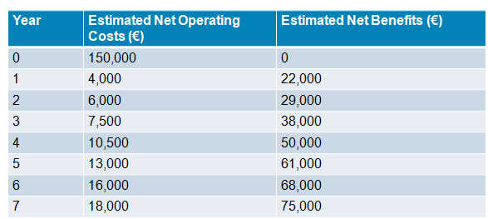

- What would the payback-period be for this proposed investment?

150,000 = Initial Investment
4,000 + 6,000 + 7,500 + 10,500 + 13,000 + 16,000 + 18,000 = 75,000
150,000/75,000 = 2 year payback period

- What is the return-on-investment, ROI, for this proposed investment?

18,000 – 150,000 / 150,000 * 100 = 17,900

- What is the net present value, NPV, of this proposed investment, if the current discount rate is 5.0%?

NPV @ 5% = 150000/(1 + 0.05)^0 + 4000/(1 + 0.05)^1 + 6000/(1 + 0.05)^2 + 7500/(1 + 0.05)^3 + 10500/(1 + 0.05)^4 + 13000/(1 + 0.05)^5 + 16000/(1 + 0.05)^6 + 18000/(1 + 0.05)^7 = 209,286.41 = 209,286

Note: Use the version control tool, git, to maintain a secure, searchable history of your Project Charter artefact’s evolution.

